Regulatory Sandbox
Summary: A regulatory sandbox allows for the testing of innovative AI products in a real-world setting, with relaxed regulatory requirements, on a time-limited basis, at a smaller scale, and with appropriate safeguards in place.
Type of pattern: Governance pattern
Type of objective: Trustworthiness
Target users: RAI governors
Impacted stakeholders: AI technology producers and procurers, AI solution producers and procurers, RAI tool producers and procurers
Lifecycle stages: All stages
Relevant AI ethics principles: Human, societal and environmental wellbeing, human-centered values, fairness, privacy protection and security, reliability and safety, transparency and explainability, contestability, accountability
Mapping to AI regulations/standards: EU AI Act, ISO/IEC 42001:2023 Standard.
Context: As AI becomes more widespread in society, both organizations and individuals have called for clearer rules to ensure that it is developed and used responsibly. RAI laws and regulations refer to government rules and policies that oversee and advance AI technology. While the policies and rules are necessary to both advance AI and mitigate related RAI risks, they often take a long time to enact.
Problem: How can we facilitate the trial of innovative AI products in the market?
Solution: One way to facilitate the testing of innovative AI products in the market is to create a regulatory sandbox, which enables the testing of innovative AI products in a real-world setting under relaxed regulatory requirements but with appropriate safeguards in place on a time-limited and small-scale basis [1]. Depending on the experiment, the sandbox may provide appropriate regulatory support by temporarily easing certain regulatory requirements for the duration and space of the sandbox. The sandbox can include safeguards to assess and mitigate RAI risks. Once the AI products exit the sandbox after the experiment, they must fully comply with RAI regulatory rules.
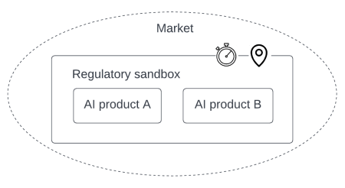
Fig.1. Regulatory sandbox.

Benefits:
- Reduced time to market: AI systems can be brought to market faster under more flexible regulatory requirements.
- Real-world trial: Companies can test their AI products in the market with real consumers and determine whether the AI product is appealing to them.
- Accelerated regulations: The regulatory sandbox allows for agile regulation, keeping pace with AI innovation.
Drawbacks:
- Increased cost: It may be additional costs associated with applying for a regulatory sandbox.
- Inconsistency with large-scale deployment: AI products tested in a regulatory sandbox may not perform as well when deployed at a larger scale or in a different context.
Related patterns:
- RAI law and regulation: A regulatory sandbox can be implemented temporarily while RAI laws and regulations are being developed.
Known uses:
- EU’s AI Regulatory Sandbox is introduced in the EU’s Artificial Intelligence Act proposal submitted in April 2021.
- The UK Information Commissioner’s Office (ICO) introduced a Regulatory Sandbox for the services and products which utilises personal data.
- The Australian Government released the Enhanced Regulatory Sandbox for innovative financial services without the need to meet existing regulatory requirements.
- Singapore’s FinTech Regulatory Sandbox allows financial companies to test with innovative financial products and services in a live environment with relaxed regulatory requirements.
References:
[1] J. Schaich Borg, “Four investment areas for ethical ai: Transdisciplinary opportunities to close the publication-to-practice gap,” Big Data & Society, vol. 8, no. 2, p. 20539517211040197, 2021.

